# Good designs:

[outofnothing.co.uk](https://outofnothing.co.uk/)

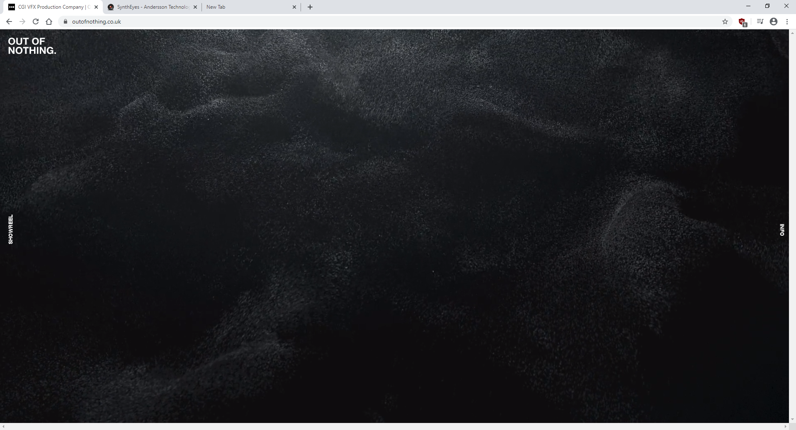

* Minimalist
* The design scales to the screen size

[sidefx.com](https://www.sidefx.com/)

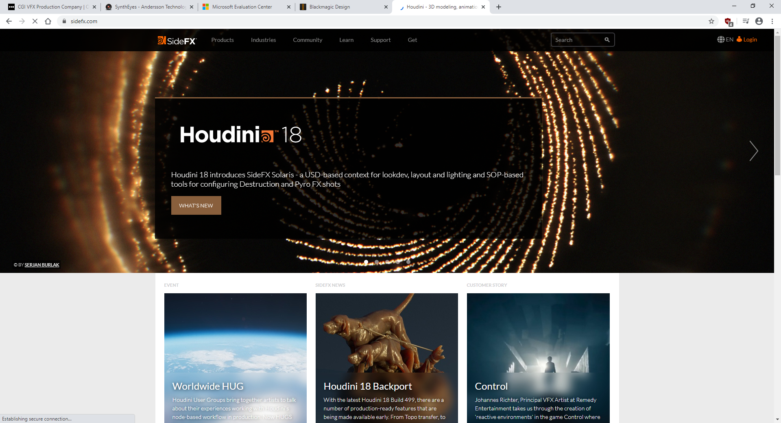

* Pretty pictures
* Navigation bar to find what you are looking for quickly
* Articles to inform you of their product

[blender.org](https://www.blender.org/)

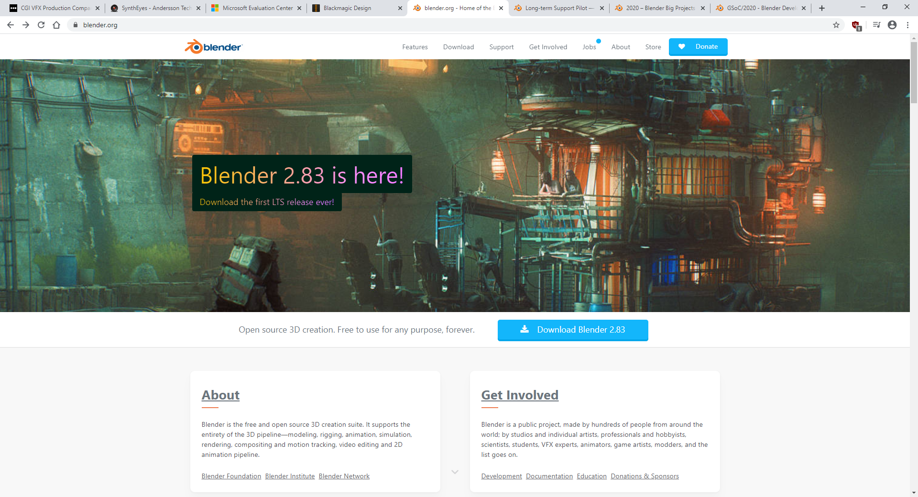

Positives:

* Starts with a nice picture
* Contains most important info on the main page

Negatives:

* A lot of pages on blender.org cannot be accessed without going through several pages or web searching for it or knowing the URL.

[artstation.com](https://www.artstation.com/)

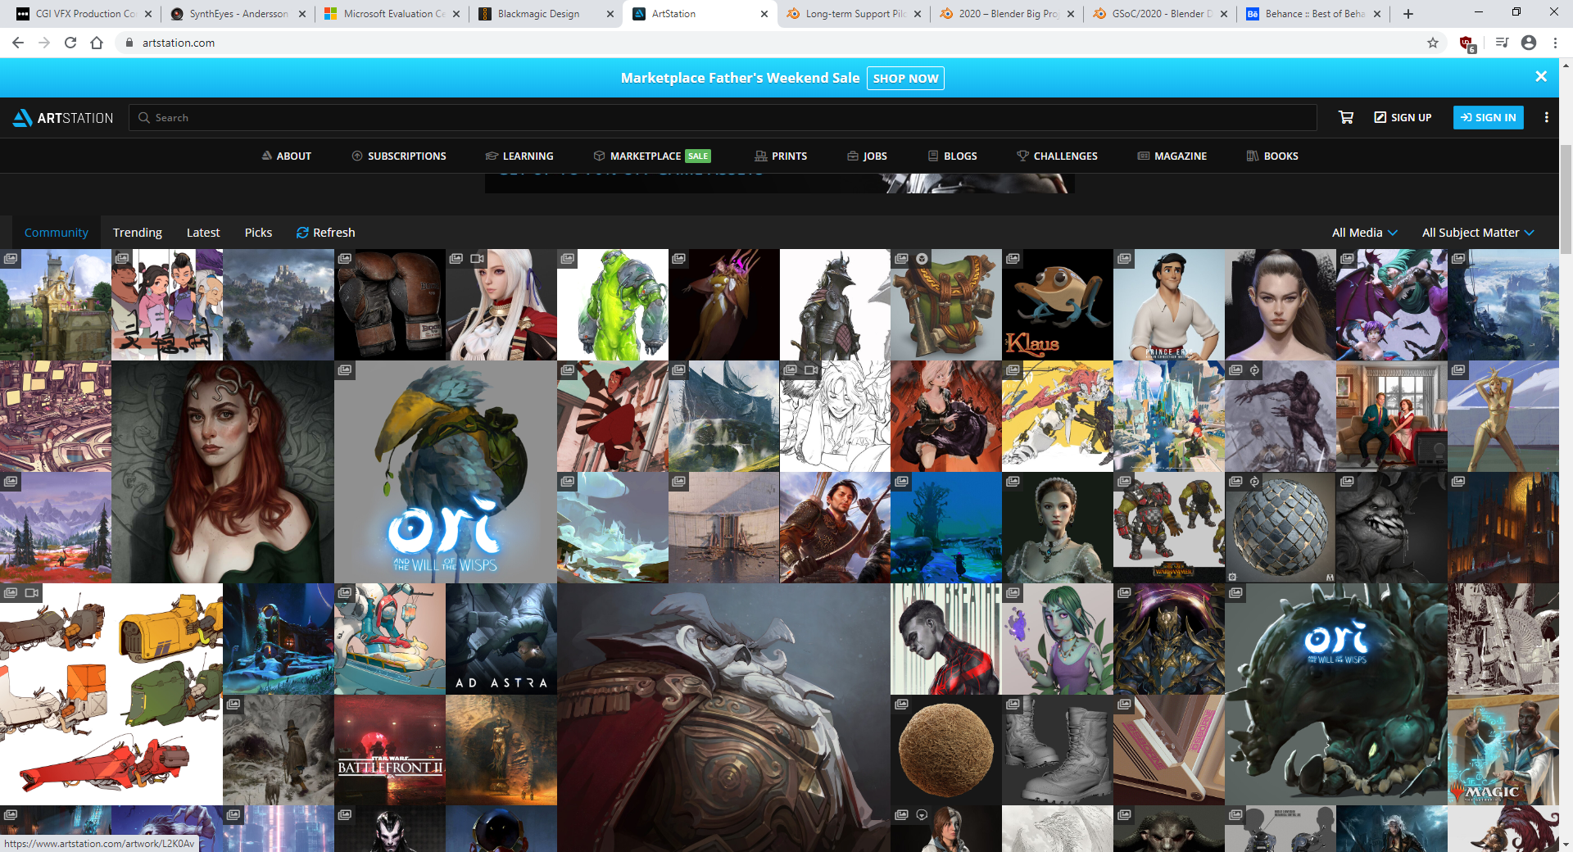Positives:

* Some images are larger than others